Инфологическая модель
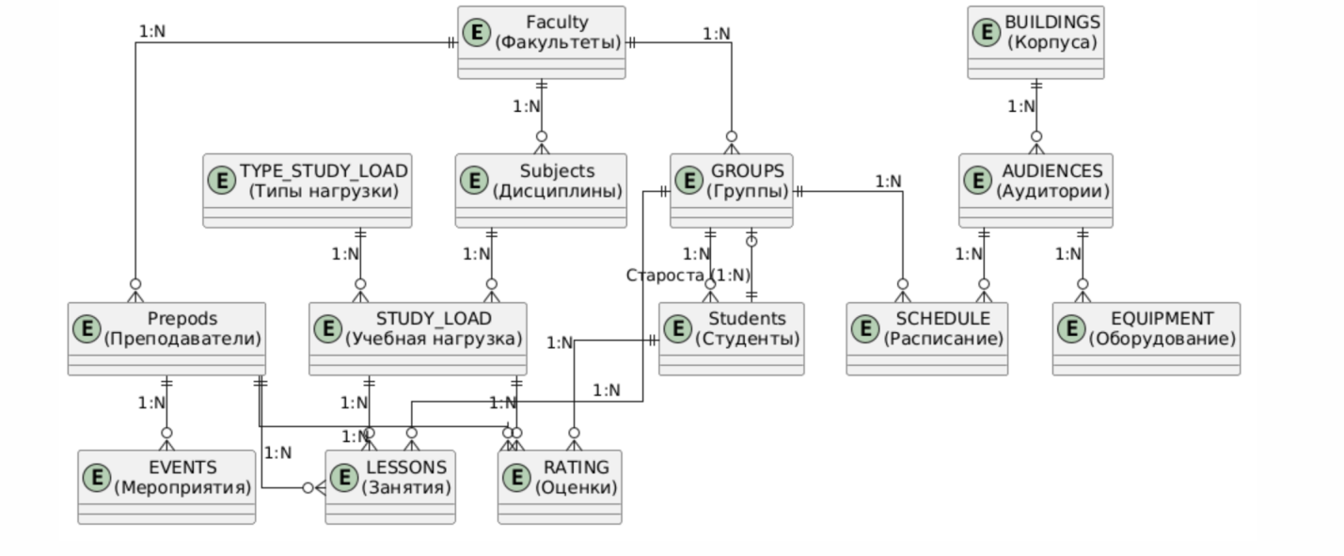
Даталогическая модель
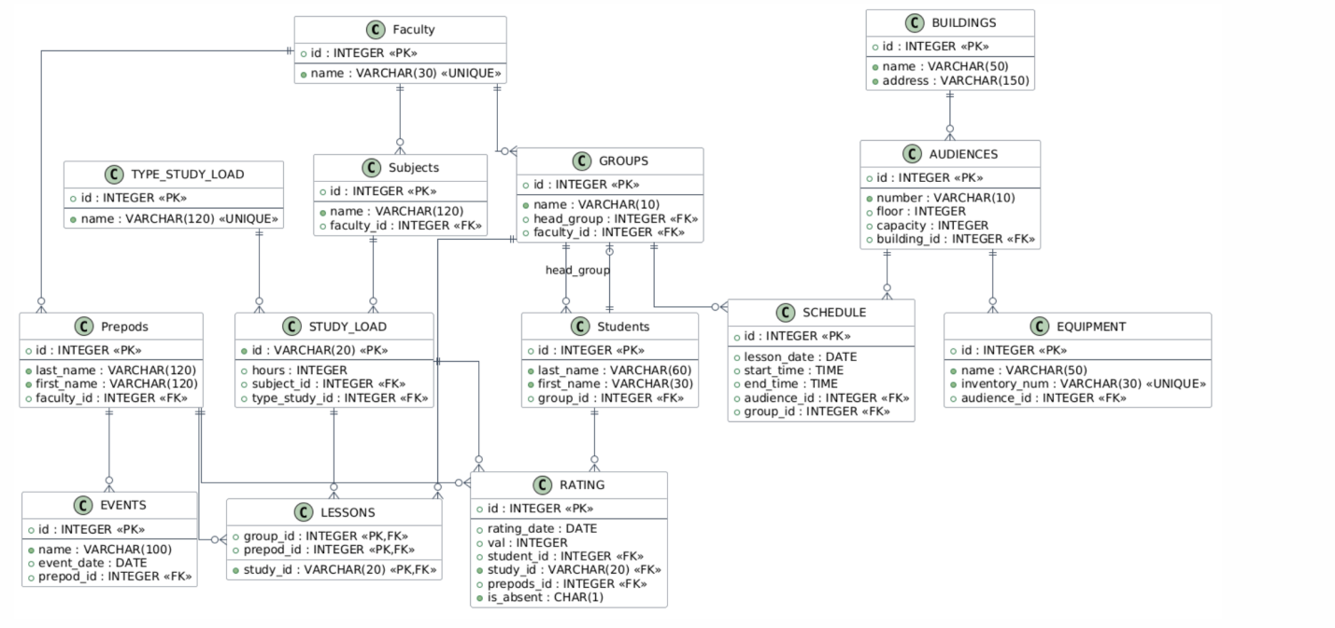

ER-диаграмма
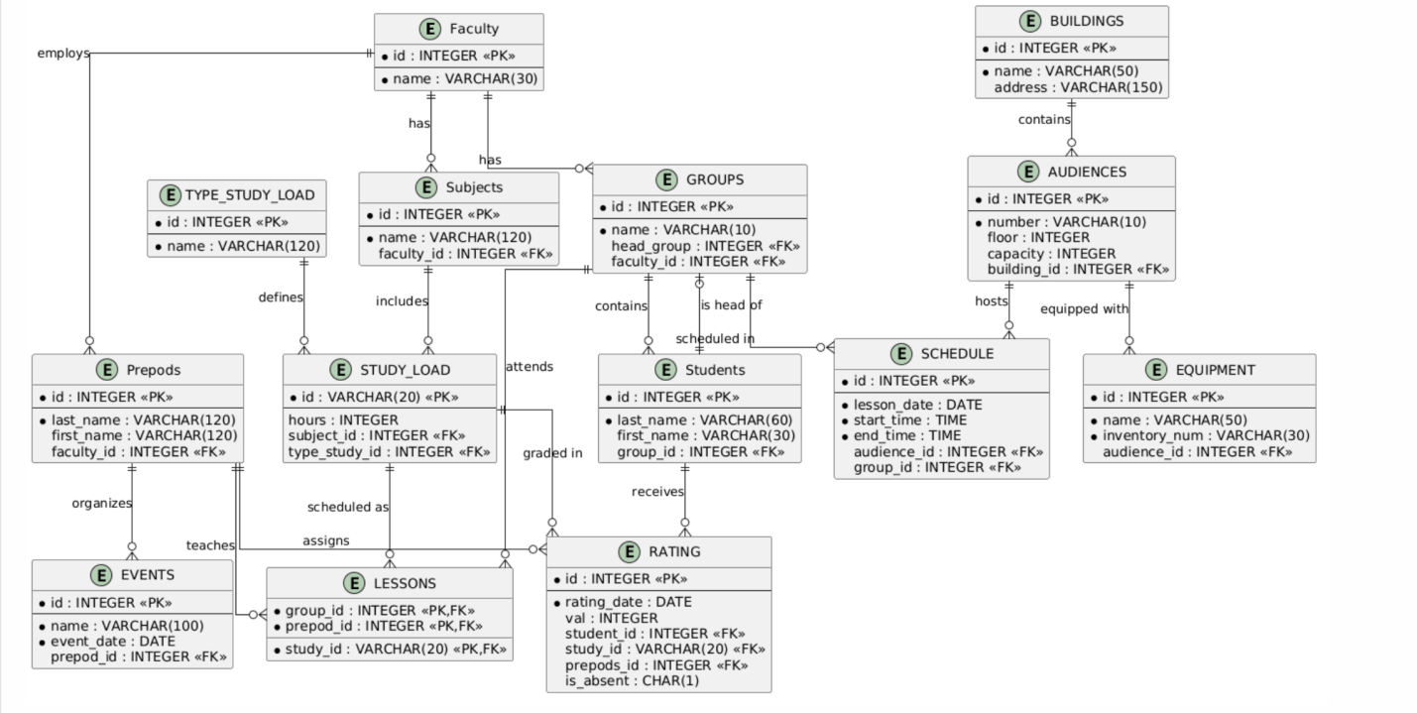
DROP TABLE IF EXISTS EVENTS CASCADE;
DROP TABLE IF EXISTS SCHEDULE CASCADE;
DROP TABLE IF EXISTS EQUIPMENT CASCADE;
DROP TABLE IF EXISTS AUDIENCES CASCADE;
DROP TABLE IF EXISTS BUILDINGS CASCADE;
DROP TABLE IF EXISTS RATING CASCADE;
DROP TABLE IF EXISTS LESSONS CASCADE;
DROP TABLE IF EXISTS Students CASCADE;
DROP TABLE IF EXISTS GROUPS CASCADE;
DROP TABLE IF EXISTS STUDY_LOAD CASCADE;
DROP TABLE IF EXISTS Prepods CASCADE;
DROP TABLE IF EXISTS Subjects CASCADE;
DROP TABLE IF EXISTS TYPE_STUDY_LOAD CASCADE;
DROP TABLE IF EXISTS Faculty CASCADE;

CREATE TABLE if not exists Faculty (
id INTEGER PRIMARY KEY,
name VARCHAR(30) NOT NULL UNIQUE
);

CREATE TABLE TYPE_STUDY_LOAD (
id INTEGER PRIMARY KEY,
name VARCHAR(120) NOT NULL UNIQUE
);

CREATE TABLE Subjects (
id INTEGER PRIMARY KEY,
name VARCHAR(120) NOT NULL,
faculty_id INTEGER
);

CREATE TABLE Prepods (
id INTEGER PRIMARY KEY,
last_name VARCHAR(120) NOT NULL,
first_name VARCHAR(120),
faculty_id INTEGER
);

CREATE TABLE STUDY_LOAD (
id VARCHAR(20) PRIMARY KEY,
hours INTEGER CHECK (hours >= 0),
subject_id INTEGER,
type_study_id INTEGER
);

CREATE TABLE GROUPS (
id INTEGER PRIMARY KEY,
name VARCHAR(10) NOT NULL,
head_group INTEGER,
faculty_id INTEGER
);

CREATE TABLE Students (
id INTEGER PRIMARY KEY,
last_name VARCHAR(60) NOT NULL,
first_name VARCHAR(30),
group_id INTEGER
);

CREATE TABLE LESSONS (
group_id INTEGER,
prepod_id INTEGER,
study_id VARCHAR(20),
PRIMARY KEY (group_id, prepod_id, study_id)
);

CREATE TABLE RATING (
id INTEGER PRIMARY KEY,
rating_date DATE NOT NULL,
val INTEGER CHECK (val > 3 AND val <= 10),
student_id INTEGER,
study_id VARCHAR(20),
prepods_id INTEGER,
is_absent CHAR(1) DEFAULT 'N'
);

CREATE TABLE BUILDINGS (
id INTEGER PRIMARY KEY,
name VARCHAR(50) NOT NULL,
address VARCHAR(150)
);

CREATE TABLE AUDIENCES (
id INTEGER PRIMARY KEY,
number VARCHAR(10) NOT NULL,
floor INTEGER,
capacity INTEGER,
building_id INTEGER
);

CREATE TABLE EQUIPMENT (
id INTEGER PRIMARY KEY,
name VARCHAR(50) NOT NULL,
inventory_num VARCHAR(30) UNIQUE,
audience_id INTEGER
);

CREATE TABLE SCHEDULE (
id INTEGER PRIMARY KEY,
lesson_date DATE NOT NULL,
start_time TIME NOT NULL,
end_time TIME NOT NULL,
audience_id INTEGER,
group_id INTEGER
);

CREATE TABLE EVENTS (
id INTEGER PRIMARY KEY,
name VARCHAR(100) NOT NULL,
event_date DATE NOT NULL,
prepod_id INTEGER
);

ALTER TABLE Subjects ADD CONSTRAINT fk_subjects_faculty
FOREIGN KEY (faculty_id) REFERENCES Faculty(id);
ALTER TABLE Prepods ADD CONSTRAINT fk_prepods_faculty
FOREIGN KEY (faculty_id) REFERENCES Faculty(id);
ALTER TABLE STUDY_LOAD ADD CONSTRAINT fk_study_subject
FOREIGN KEY (subject_id) REFERENCES Subjects(id);
ALTER TABLE STUDY_LOAD ADD CONSTRAINT fk_study_type
FOREIGN KEY (type_study_id) REFERENCES TYPE_STUDY_LOAD(id);

ALTER TABLE GROUPS ADD CONSTRAINT fk_groups_faculty
FOREIGN KEY (faculty_id) REFERENCES Faculty(id);
ALTER TABLE Students ADD CONSTRAINT fk_students_group
FOREIGN KEY (group_id) REFERENCES GROUPS(id);

ALTER TABLE GROUPS ADD CONSTRAINT fk_groups_head
FOREIGN KEY (head_group) REFERENCES Students(id);

ALTER TABLE LESSONS ADD CONSTRAINT fk_lessons_group
FOREIGN KEY (group_id) REFERENCES GROUPS(id);
ALTER TABLE LESSONS ADD CONSTRAINT fk_lessons_prepod
FOREIGN KEY (prepod_id) REFERENCES Prepods(id);
ALTER TABLE LESSONS ADD CONSTRAINT fk_lessons_study
FOREIGN KEY (study_id) REFERENCES STUDY_LOAD(id);

ALTER TABLE RATING ADD CONSTRAINT fk_rating_student
FOREIGN KEY (student_id) REFERENCES Students(id);
ALTER TABLE RATING ADD CONSTRAINT fk_rating_study
FOREIGN KEY (study_id) REFERENCES STUDY_LOAD(id);
ALTER TABLE RATING ADD CONSTRAINT fk_rating_prepod
FOREIGN KEY (prepods_id) REFERENCES Prepods(id);

ALTER TABLE AUDIENCES ADD CONSTRAINT fk_audiences_building
FOREIGN KEY (building_id) REFERENCES BUILDINGS(id);
ALTER TABLE EQUIPMENT ADD CONSTRAINT fk_equipment_audience
FOREIGN KEY (audience_id) REFERENCES AUDIENCES(id);
ALTER TABLE SCHEDULE ADD CONSTRAINT fk_schedule_audience
FOREIGN KEY (audience_id) REFERENCES AUDIENCES(id);
ALTER TABLE SCHEDULE ADD CONSTRAINT fk_schedule_group
FOREIGN KEY (group_id) REFERENCES GROUPS(id);
ALTER TABLE EVENTS ADD CONSTRAINT fk_events_prepod
FOREIGN KEY (prepod_id) REFERENCES Prepods(id);

INSERT INTO Faculty VALUES (1, 'Информатика');
INSERT INTO Faculty VALUES (2, 'Математика');

INSERT INTO TYPE_STUDY_LOAD VALUES (1, 'Лекции');
INSERT INTO TYPE_STUDY_LOAD VALUES (2, 'Практика');
INSERT INTO TYPE_STUDY_LOAD VALUES (3, 'Лабораторные');

INSERT INTO Subjects VALUES (1, 'Базы данных', 1);
INSERT INTO Subjects VALUES (2, 'Алгоритмы', 1);
INSERT INTO Subjects VALUES (3, 'Матанализ', 2);

INSERT INTO Prepods VALUES (1, 'Иванов', 'Иван', 1);
INSERT INTO Prepods VALUES (2, 'Петров', 'Петр', 2);
INSERT INTO Prepods VALUES (3, 'Сидорова', 'Анна', 1);

INSERT INTO STUDY_LOAD VALUES ('SL001', 36, 1, 1);
INSERT INTO STUDY_LOAD VALUES ('SL002', 18, 2, 2);
INSERT INTO STUDY_LOAD VALUES ('SL003', 54, 1, 3);
INSERT INTO STUDY_LOAD VALUES ('SL004', 36, 3, 1);

INSERT INTO Students VALUES (1, 'Сидоров', 'Алексей', NULL);
INSERT INTO Students VALUES (2, 'Козлов', 'Дмитрий', NULL);
INSERT INTO Students VALUES (3, 'Новикова', 'Мария', NULL);
INSERT INTO Students VALUES (4, 'Волков', 'Андрей', NULL);

INSERT INTO GROUPS VALUES (1, 'ИВТ-21', 1, 1);
INSERT INTO GROUPS VALUES (2, 'МТ-21', 2, 2);

UPDATE Students SET group_id = 1 WHERE id IN (1, 3);
UPDATE Students SET group_id = 2 WHERE id IN (2, 4);

INSERT INTO LESSONS VALUES (1, 1, 'SL001');
INSERT INTO LESSONS VALUES (1, 3, 'SL003');
INSERT INTO LESSONS VALUES (2, 2, 'SL004');

INSERT INTO RATING VALUES (1, '2026-09-20', 8, 1, 'SL001', 1, 'N');
INSERT INTO RATING VALUES (2, '2026-09-21', 9, 2, 'SL004', 2, 'N');
INSERT INTO RATING VALUES (3, '2026-09-22', 7, 3, 'SL003', 3, 'N');
INSERT INTO RATING VALUES (4, '2026-09-23', 10, 4, 'SL004', 2, 'Y');

INSERT INTO BUILDINGS VALUES (1, 'Главный корпус', 'ул. Университетская, 1');
INSERT INTO BUILDINGS VALUES (2, 'Лабораторный корпус', 'ул. Университетская, 3');
INSERT INTO BUILDINGS VALUES (3, 'Библиотека', 'ул. Университетская, 5');

INSERT INTO AUDIENCES VALUES (1, '101', 1, 30, 1);
INSERT INTO AUDIENCES VALUES (2, '205', 2, 25, 2);
INSERT INTO AUDIENCES VALUES (3, '310', 3, 100, 1);

INSERT INTO EQUIPMENT VALUES (1, 'Проектор Epson', 'EQ-001', 1);
INSERT INTO EQUIPMENT VALUES (2, 'Компьютер Dell', 'EQ-002', 2);
INSERT INTO EQUIPMENT VALUES (3, 'Интерактивная доска', 'EQ-003', 3);

INSERT INTO SCHEDULE VALUES (1, '2026-09-25', '09:00', '10:30', 1, 1);
INSERT INTO SCHEDULE VALUES (2, '2026-09-25', '11:00', '12:30', 2, 2);
INSERT INTO SCHEDULE VALUES (3, '2026-09-26', '14:00', '15:30', 3, 1);

INSERT INTO EVENTS VALUES (1, 'День открытых дверей', '2026-10-01', 1);
INSERT INTO EVENTS VALUES (2, 'Олимпиада по программированию', '2026-10-15', 3);
INSERT INTO EVENTS VALUES (3, 'Научная конференция', '2026-11-20', 2);

SELECT 'Faculty' AS таблица, COUNT(*) AS строк FROM Faculty
UNION ALL SELECT 'TYPE_STUDY_LOAD', COUNT(*) FROM TYPE_STUDY_LOAD
UNION ALL SELECT 'Subjects', COUNT(*) FROM Subjects
UNION ALL SELECT 'Prepods', COUNT(*) FROM Prepods
UNION ALL SELECT 'STUDY_LOAD', COUNT(*) FROM STUDY_LOAD
UNION ALL SELECT 'GROUPS', COUNT(*) FROM GROUPS
UNION ALL SELECT 'Students', COUNT(*) FROM Students
UNION ALL SELECT 'LESSONS', COUNT(*) FROM LESSONS
UNION ALL SELECT 'RATING', COUNT(*) FROM RATING
UNION ALL SELECT 'BUILDINGS', COUNT(*) FROM BUILDINGS
UNION ALL SELECT 'AUDIENCES', COUNT(*) FROM AUDIENCES
UNION ALL SELECT 'EQUIPMENT', COUNT(*) FROM EQUIPMENT
UNION ALL SELECT 'SCHEDULE', COUNT(*) FROM SCHEDULE
UNION ALL SELECT 'EVENTS', COUNT(*) FROM EVENTS;

